Bahria University,

Karachi Campus

## LAB EXPERIMENT NO.

10

## LIST OF TASKS

|  |  |
| --- | --- |
| **TASK NO** | **OBJECTIVE** |
| **1** | An automotive company wants to identify and treat outliers in their "mtcars" dataset. which contains information about various car models. They suspect that certain car models might have outlier values in certain variables and want to analyze and handle them using Python. |
| **2** | An automotive company wants to identify and treat outliers in their "mtcars" dataset. which contains information about various car models. They suspect that certain car models might have outlier values in certain variables and want to analyze and handle them using Python. |

Submitted On:

08 may 2024

(Date: DD/MM/YY)

**TASK#1:** An automotive company wants to identify and treat outliers in their "mtcars" dataset. which contains information about various car models. They suspect that certain car models might have outlier values in certain variables and want to analyze and handle them using Python.

import pandas as pd

import numpy as np

import matplotlib.pyplot as plt

from pydataset import data

mtcars = data('mtcars')

variables_of_interest = ['mpg', 'disp', 'hp', 'drat', 'wt', 'qsec']

plt.figure(figsize=(10, 6))

mtcars[variables_of_interest].boxplot()

plt.title('Box Plot for Outlier Detection')

plt.xticks(rotation=45)

plt.show()

from scipy.stats import zscore

z_scores = zscore(mtcars[variables_of_interest])

abs_z_scores = np.abs(z_scores)

outliers_zscore = (abs_z_scores > 3).any(axis=1)

print("Outliers detected using Z-score method:")

print(mtcars[outliers_zscore])

Q1 = mtcars[variables_of_interest].quantile(0.25)

Q3 = mtcars[variables_of_interest].quantile(0.75)

IQR = Q3 - Q1

lower_bound = Q1 - 1.5 * IQR

upper_bound = Q3 + 1.5 * IQR

outliers_iqr = ((mtcars[variables_of_interest] < lower_bound) | (mtcars[variables_of_interest] > upper_bound)).any(axis=1)

print("\nOutliers detected using IQR method:")

print(mtcars[outliers_iqr])

plt.figure(figsize=(10, 6))

for var in variables_of_interest:

    plt.scatter(mtcars.index, mtcars[var], label=var)

threshold_value = 300

plt.axhline(y=threshold_value, color='r', linestyle='--', label=f'Threshold: {threshold_value}')

plt.title('Scatter Plot for Outlier Detection with Threshold')

plt.xlabel('Index')

plt.ylabel('Values')

plt.legend()

plt.show()

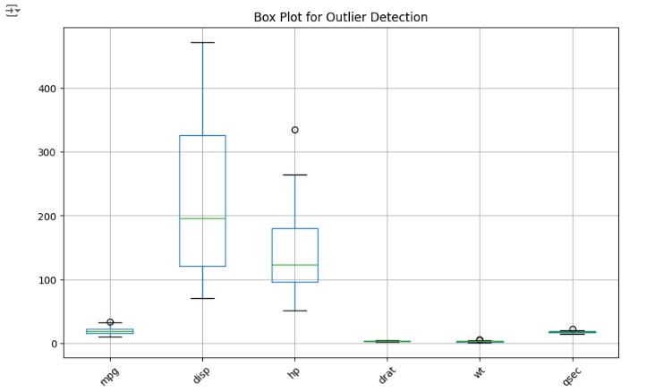

**TASK #2:** An automotive company wants to identify and treat outliers in their "mtcars" dataset. which contains information about various car models. They suspect that certain car models might have outlier values in certain variables and want to analyze and handle them using Python.

import pandas as pd

import numpy as np

import seaborn as sns

import matplotlib.pyplot as plt

mtcars = sns.load_dataset('mpg')

def detect_and_treat_outliers_scatter(df, x_column, y_column):

    plt.figure(figsize=(8, 6))

    sns.scatterplot(x=x_column, y=y_column, data=df)

    plt.title(f'Scatter plot of {x_column} vs {y_column}')

    plt.show()

def detect_and_treat_outliers_histogram(df, column):

    plt.figure(figsize=(8, 6))

    sns.histplot(df[column], kde=True)

    plt.title(f'Histogram of {column}')

    plt.xlabel(column)

    plt.ylabel('Frequency')

    plt.show()

def detect_and_treat_outliers_boxplot(df, column):

    plt.figure(figsize=(8, 6))

    sns.boxplot(x=df[column])

    plt.title(f'Boxplot of {column}')

    plt.show()

def detect_and_treat_outliers_zscore(df, column, threshold=3):

    z_scores = np.abs((df[column] - df[column].mean()) / df[column].std())

    outliers = df[z_scores > threshold]

    df_cleaned = df[z_scores <= threshold]

    return df_cleaned, outliers

def detect_and_treat_outliers_iqr(df, column):

    Q1 = df[column].quantile(0.25)

    Q3 = df[column].quantile(0.75)

    IQR = Q3 - Q1

    lower_bound = Q1 - 1.5 * IQR

    upper_bound = Q3 + 1.5 * IQR

    outliers = df[(df[column] < lower_bound) | (df[column] > upper_bound)]

    df_cleaned = df[(df[column] >= lower_bound) & (df[column] <= upper_bound)]

    return df_cleaned, outliers

detect_and_treat_outliers_scatter(mtcars, 'mpg', 'weight')

detect_and_treat_outliers_histogram(mtcars, 'mpg')

detect_and_treat_outliers_boxplot(mtcars, 'mpg')

mtcars_cleaned_zscore, outliers_zscore = detect_and_treat_outliers_zscore(mtcars, 'mpg')

print("Outliers detected using z-score method:\n", outliers_zscore)

mtcars_cleaned_iqr, outliers_iqr = detect_and_treat_outliers_iqr(mtcars, 'mpg')

print("Outliers detected using IQR method:\n", outliers_iqr)

